**Zenithzens**

Project Divine

**Eluisa, Brandon, Alfredo**

**Work in Progress**

**Full View (No UI)**

Test view of most of the assets together.

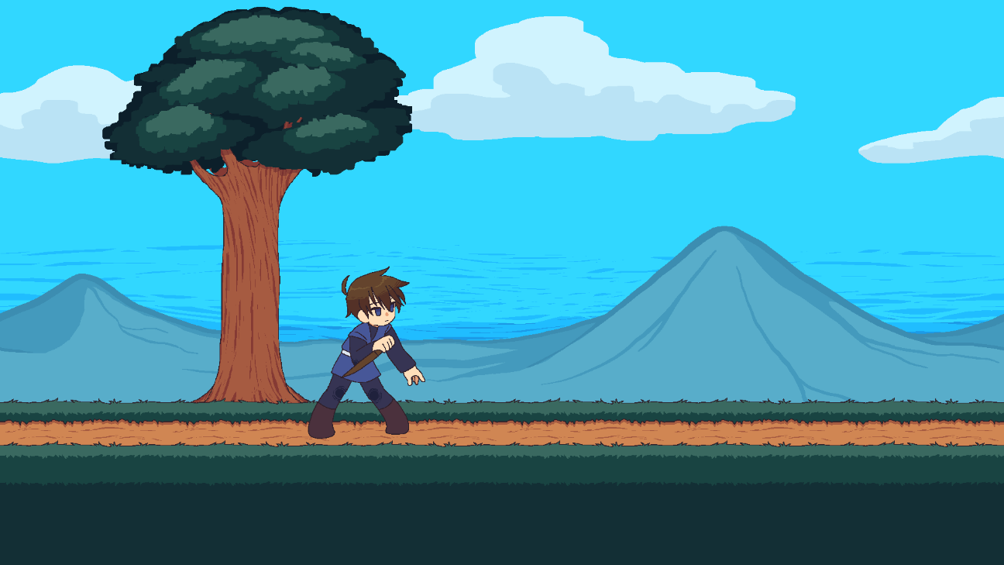

**Character (Noah)**

The Main Character, Former 13th of The Thirteen Divine. Idle Animation might change in the future.



**Path (Unfinished Tilesets)**

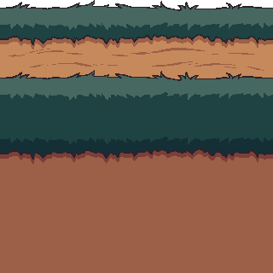

**Background Assets**





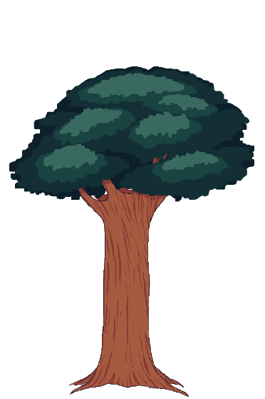

**Future Assets**

Enemy

* Wolf
* Snake
* Levina

Tileset

* Rocky
* Full Grass
* Full Dirt

Background

* Forest
* Temple

UI

* Logo
* Status Bar
* Inventory
* Menu
* Chatbox(?)

Effect

* Particles
* Cut-In

**Artistic Reference: None**

**Gameplay Reference: Grand Chase, Elsword**

